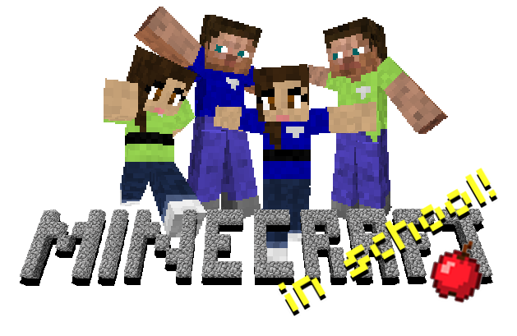brought to you by:
Ms. Toothman
at West Pender Middle School

Welcome Explorers!

This semester we will be learning about and exploring Minecraft.

So, what is Minecraft?
Minecraft is an independently developed video game created by Markus "Notch" Persson. Based on the Java programming language, the game is considered a "sandbox" game. It provides players with a large virtual world consisting of blocks of various materials (dirt, stone, iron, wood, etc.) that can be broken down and crafted into a variety of tools and structures.
Currently, the game offers two basic modes of play:
Classic - the simplest game mechanics are used. Players have an unlimited number of blocks with which to build.
Beta - adds a great deal of complexity to the basic mechanics of Classic mode. Here, players collect resources and develop new items through a variety of recipes. This mode also allows for "monsters" to be added to the game world.

The Story So Far...
You don’t remember much. You know there was a big storm. Lightning flashed across the sky as the wind howled, tearing at the sails of the ship.
...the ship. You were aboard an exploration vessel, but now you’re here. You seem to remember the crash, but it’s all very foggy in your mind now.
As best you can tell, this place is uninhabited except by a few animals. As you look around, you can see your fellow shipmates around you, all wearing their explorer’s uniforms.
Your chances of rescue are slim, so you’ll have to work together to gather resources and build a new town so each of you can survive. This new world is yours. What will you build?

Schedule:
- B Days play the game and work on quests
- A/B Days work on Explorer's Blog

Grading and Expectations:
- Grades will be earned through gaining experience points and leveling up
- Grades can be tracked through each student's individual Gamer Card kept in the classroom as well as the leveling chart.
  - Each student is expected to participate each day in game or through their Explorer's Blog.
  - Students can level up by completing quests.
  - Students can earn badges by completing quests and various accomplishments (i.e. most attractive home).
  - Students can lose experience points for disrupting another player's gaming experience (i.e. destroying another player's crafted structure)
  - Gaming Abuse (griefing, threatening, or other foul play) will result in the loss of gaming privileges for the day. Repeated Game Abuse will result in disciplinary action by WPMS administration.

Explorer's Blog:
All great explorers document their findings and achievements through a log. We will do the same to record what we experience through the game. The Explorer's Log will be a digital blog created through Edmodo. Explorers will set up their Blog and relay the observations, feelings, experiences, questions, and challenges about their time in the world of Minecraft, thus building their writing skills. Explorer Blogs will include screenshots, drawings, monster manuals, how-to's, and other tales of intrigue.

Minecraft Game Controls and Tutorials:
- W, A, S, D for movement. Using the Mouse to Look. Left click to break things. Right click to place or use things. Spacebar to jump. “T” to chat with each other. “I” to access their inventory. Mouse wheel to change what item they’re holding.
- Day 1: http://www.minecraftwiki.net/wiki/Tutorials/Beginner%27s_guide
- Day 2: http://www.minecraftwiki.net/wiki/The_Second_Day

Quest List
- Day 1 - Survive your first night
  - Get 10 logs: See note below
  - Get 3 wool blocks
  - Make a crafting table
  - Make a wooden pickaxe
  - Get 11 cobblestone*
  - Make a stone pickaxe
  - Get about 4 saplings (these are found when you chop leaves in a tree)
- Build a shelter
  - Make a bed
  - Start on shelter (materials depend, not counted)
  - Create a door for your shelter
  - Create a storage chest and place it in the shelter
  - Create a furnace
  - Smelt 1 log to make charcoal unless you found coal
  - Create some torches and place them
- Survive a monster attack
- Writing prompts
- Build a two-story home
  - http://www.minecraftwiki.net/wiki/Tutorials/List_of_things_to_do_to_your_shelter
- Start a farm to always have food on hand.
- Start a mine down to the bedrock and stockpile minerals.
- Craft upgraded tools all the way to diamond.
- Craft and wear armor at all times, working your way up to diamond.
- Build a statue of a video game icon
- Bake a cake
- Build a fish tank
- Obtain obsidian from your mine to build a nether portal.
- Travel from your home in search of the various types of food to add to your farm.
- Combat the creatures in the over world while exploring the villages, ruins and biomes.
- monster manual - hand drawn or digital
- While traveling, collect the many resources yet to be encountered for the additional crafting recipes.
- Return to your home and expand your mine searching for dungeons, caverns and abandoned mine shafts.
- Construct your portal to the nether and travel there to collect resources while exploring.
- Return to your home and further expand/craft.
- Seek out an Ender portal and travel to The End.
- Make a mob trap and get resources (gunpowder, string, arrows, etc.)
- PROJECT - BUILD 3d Model of something THEY"VE BUILT IN THE GAME
- This list doesn't really end here - explore and build. Go for it!

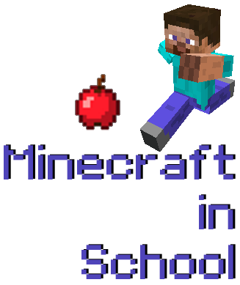
Dear Parent/Guardian,

We would like to invite your child to participate in an exciting new project that we’re piloting at West Pender Middle School. This project focuses on a game-based approach to learning using a computer game called Minecraft. This will take place during electives on B days.

Minecraft is an independently developed video game that has grown rapidly in popularity among online game players. It is what is commonly referred to as a “sandbox” game, or a virtual space for players to explore and build nearly anything they can imagine. Our students will work cooperatively in this virtual world not only with their fellow West Pender peers, but also with students from Topsail Elementary, Pender Early College, and Cape Fear Middle.

Through this experience, we’ll be exploring the basics of design, planning, spatial reasoning, teamwork and leadership in a way that will engage higher-order thinking skills, all while playing in an immersive game world. Our students will be focusing on the Essential Standards for Science Education, grades 6-8 while on their Minecraft journey.
If you would like to know more about Minecraft, take a look at their website (http://www.minecraft.net) or read the article about the game on Wikipedia (http://en.wikipedia.org/wiki/Minecraft). Our Minecraft server will be hosted internally on our district’s network, so your child will only be learning with fellow students and district employees. Essentially, we will share an enclosed world open only to Pender County students.

As this program develops we would also love to share your child’s work with the world. We feel this gives them not only a sense of ownership of their learning, but also helps to connect that learning to a global future.

This is an exciting opportunity and we hope you will consider it. If you would like your child to participate and agree to let us share their creations online, please sign below. Should your child participate, we also encourage you to visit the class and watch the exciting learning taking place.
If you have any questions, please contact Sara Toothman at West Pender Middle School, sara_toothman@pender.k12.nc.us.

Sincerely,

I consent to allow my child, ________________________, to participate in the Minecraft in School program and for their work to be shared online.

Signature:  ___________________________________ | Print:  __________________________________

